主旨：S220 G/C (group controller),Dec servo port access configure database。
目的：1.在於利用爐管機台的 SECS 功能進行程式下載 (Recipe Download) ，使EA只需將批號輸入本系統的操作介面，系統便可依據工程師事先依據Route與 Operation 所定義好的Recipe自動下載給Furnace Equipment並自動查核正確性，且能自動讓 Furnace Equipment 開始RUN貨。如此一來EA便不需每次RUN貨就必須到機台前面選擇程式，且可避免選錯程式所導致產品報廢的損失。
2.建立 G/C (group controller),Dec servo port access configure，藉由整個系統流程可明確瞭解，整個爐管區 automation auto download recipe ，Dec servo 分佈區域之架構，於 Dec servo →VAX lan system〝 M/D〞時可依據建立的 configure database ，使得 HP engineer 參考當機問題(狀況)，迅速瞭解原因作出最佳之處理，予以縮短 system down 之時間。

- furnace Dec servo( 700型 ) port area 架構：
- win310 port use:(G/C → utilities → 11 show communication → return)。
➔F01 F02 F03 F04 F05 F06 F07 F08 F09 F10 F11 F12 F14 F15 F17 F18 F19 F23 F24 F42 F44。
➔H-F01 H-F02 H-F03 H-F04 H-F05 H-F06 H-F07 H-F08 H-F09 H-F10 H-F11 H-F12 H-F14 H-F15 H-F17 H-F18 H-F19 H-F23 H-F24 H-F42 H-F44 T-F01 T-F02 T-F03 T-F04 T-F05 T-F06 T-F07 T-F08 T-F09 T-F10 T-F11 T-F12 T-F14 T-F15 T-F17 T-F18 T-F19 T-F23 T-F24 T-F42
T-F44。
2. win320 port use:(G/C → utilities → 11 show communication → return)。
➔F45 H-F45 H-LP-N1 H-LP-N2 H-LP-N3 H-LP-N4 H-LP-N5 H-LP-N6 H-LP-N7 H-LP-P1 H-LP-P2
H-LP-P3 H-LP-P4 H-LP-P6 H-LP-P7 H-LP-T1 H-LP-T2 H-LP-T3 H-LP-T4 H-LP-T5 H-LP-T6
H-LP-T8 LP-N1 LP-N2 LP-N3 LP-N4 LP-N5 LP-N6 LP-N7 LP-P1 LP-P2 LP-P3 LP-P4 LP-P6
➔LP-P7 LP-T1 LP-T2 LP-T3 LP-T4 LP-T5 LP-T6 LP-T8 T-F45 T-LP-N1 T-LP-N2 T-LP-N3
T-LP-N4 T-LP-N5 T-LP-N6 T-LP-N7 T-LP-P1 T-LP-P2 T-LP-P3 T-LP-P4 T-LP-P6 T-LP-P7
T-LP-T1 T-LP-T2 T-LP-T3 T-LP-T4 T-LP-T5 T-LP-T6 T-LP-T8。

3. win330 port use:(G/C → utilities → 11 show communication → return)。
➔F13 F16 F20 F21 F22 F25 F26 F27 F28 F29 F30 F39 F40 F41 I01 I02 I03 I04 I05 I06 I07。
➔H-F13 H-F16 H-F20 H-F21 H-F22 H-F25 H-F26 H-F27 H-F28 H-F29 H-F30 H-F39 H-F40
H-F41 H-I01 H-I02 H-I03 H-I04 H-I05 H-I06 H-I07 T-F13 T-F16 T-F20 T-F21 T-F22 T-F25
T-F26 T-F27 T-F28 T-F29 T-F30 T-F39 T-F40 T-F41 T-I01 T-I02 T-I03 T-I04 T-I05 T-I06 T-I07。
4.furnace G/C device servo of 配置，請 link this file !

5.furnace (group controller) to VAX Lan figure：
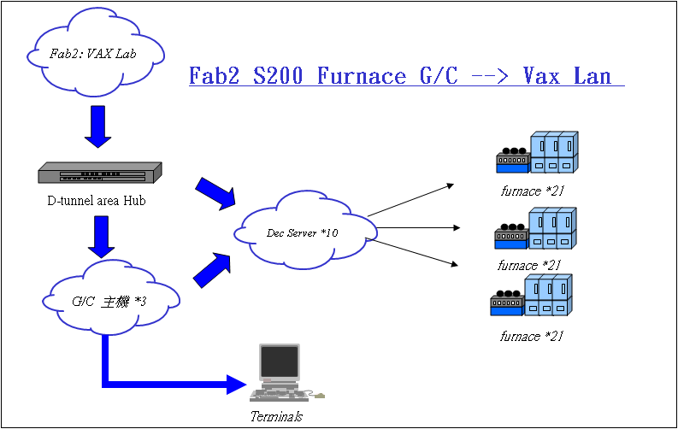
貳、confirm G/C Dsv show port 方式：
➔VMS2_PMFAN$ set h win320
Welcome to VAX/VMS V5.4-2
Username: SYSTEM
Password: SYSTEM
Welcome to VAX/VMS version V5.4-2 on node WIN320
Last interactive login on Wednesday, 29-JUN-1994 16:55
Last non-interactive login on Tuesday, 28-DEC-1993 10:53
WIN320::> mcr ncp
NCP>connect node dsv7
Console connected (press CTRL/D when finished)
# access
Network Access SW V2.3A for DS700-16 (BL47-60)
(c) Copyright 1998, Digital Equipment Corporation - All Rights Reserved
Please type HELP if you need assistance
Enter username> set priv
Local> show port all
Port Access Status Services Offered
1 Remote Connected
2 Remote Connected
3 Remote Connected
4 Remote Connected
5 Remote Connected
6 Remote Connected
7 Remote Connected
8 Remote Connected
9 Remote Connected
10 Remote Connected
11 Remote Connected
12 Remote Connected
13 Remote Idle
14 Remote Idle
15 Local Idle
16 Local Idle
Local>ctrl+z (跳出).
參、confirm active 〝node〞status 方式：
➔Username: SYSTEM
Password: SYSTEM
Welcome to VAX/VMS version V5.5-2H4 on node WIN330
Last interactive login on Sunday, 19-JUN-1994 04:00
Last non-interactive login on Tuesday, 28-DEC-1993 11:23
WIN330::> mcr ncp
NCP>sh active node
Active Node Volatile Summary as of 30-JUN-1994 08:46:59
Executor node = 1.810 (WIN330)
State = on
Identification = DECnet-VAX V5.5-2, VMS V5.5-2H4
Active links = 2
NCP>sh known node
Known Node Volatile Summary as of 30-JUN-1994 08:47:30
Executor node = 1.810 (WIN330)
State = on
Identification = DECnet-VAX V5.5-2, VMS V5.5-2H4
Active links = 2
➔Dec servo working node.
1.801 (WIN310) 1 1 ISA-0 1.1022
1.802 (WIN320) ISA-0 1.1022
1.803 (DSV1) ISA-0 1.1022
1.804 (DSV2) ISA-0 1.1022
1.805 (DSV3) ISA-0 1.1022
1.806 (DSV4) ISA-0 1.1022
1.807 (DSV5) ISA-0 1.1022
1.808 (DSV6) ISA-0 1.1022
1.809 (DSV7) ISA-0 1.1022
1.811 (DSV11) ISA-0 1.1022
1.812 (DSV12) ISA-0 1.1022
1.813 (DSV13) ISA-0 1.1022
1.815 (900TM1) ISA-0 1.1022
1.816 (900TM2) ISA-0 1.1022
NCP>

肆、show dec servo 〝 ? 〞port define setup valve：
WIN330::> mcr ncp
NCP>connect node dsv11
Console connected (press CTRL/D when finished)
# access
Set priv
Network Access SW V2.3A for DS700-16 (BL47-60)
(c) Copyright 1998, Digital Equipment Corporation - All Rights Reserved
Please type HELP if you need assistance
Enter username> system
Local> show port 11
Port 11: (Remote) Server: DSV11
Character Size: 8 Input Speed: 9600
Flow Control: None Output Speed: 9600
Parity: None Signal Control: Disabled
Stop Bits: Dynamic Signal Select: CTS-DSR-RTS-DTR
●Access: 〝 Remote〞 Local Switch: None
Backwards Switch: None Name: PORT_11
Break: Disabled Session Limit: 4
Forwards Switch: None Type: Ansi
Default Protocol: LAT Default Menu: None
Autolink Timer One:10 Two:10 Dialer Script: None
Preferred Service: None
Authorized Groups: 0
(Current) Groups: 0
Enabled Characteristics:
Failover, Lock
Local>logout
NCP>exit
WIN330::>logout ➔完成跳出系統。

※以上【例子】：為確認 dec servo 11 內，16 port 11 connect status(use show :Remote ,no use show : local)。
其他 dec servo ? 亦使用相同指令輸入(但須注意：選擇 win310..WIN320..WIN330.. 擇須確認該 G/C dec servo，才會帶出該 servo port status)。
Note：若是須進入 NCP > 底層檢視請勿修改 database value。

